Italian Cybersecurity Law 90-2024 Compliance for Log360
Tagline: Meet Italy's cybersecurity obligations with centralized log monitoring from Log360.

Overview
The Italian Cybersecurity Law 90/2024 Compliance extension for Log360 helps Italian public administrations, regulated entities, and private organizations meet the enhanced cybersecurity risk management and mandatory incident reporting requirements introduced by Law 90/2024.
Log360 continuously monitors log data from IT systems, cloud platforms, and network infrastructure, correlating events to surface threats that must be reported to ACN within the mandated timeframes. Security teams can automate detection, accelerate incident investigation, and maintain the audit trails required for regulatory compliance.

Key Features
- Generate predefined audit reports covering cybersecurity incident detection, system access, and user activity aligned to Law 90/2024 obligations.
- Receive real-time alerts on security events that trigger ACN mandatory notification requirements, such as significant IT incidents and data breaches.
- Correlate security events across your IT environment to maintain continuous visibility into user activity, access patterns, and system changes, supporting early threat identification and Law 90/2024 incident reporting requirements.
- Export compliance documentation in PDF and CSV formats for ACN incident reports and internal governance records.
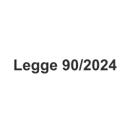


Screenshots
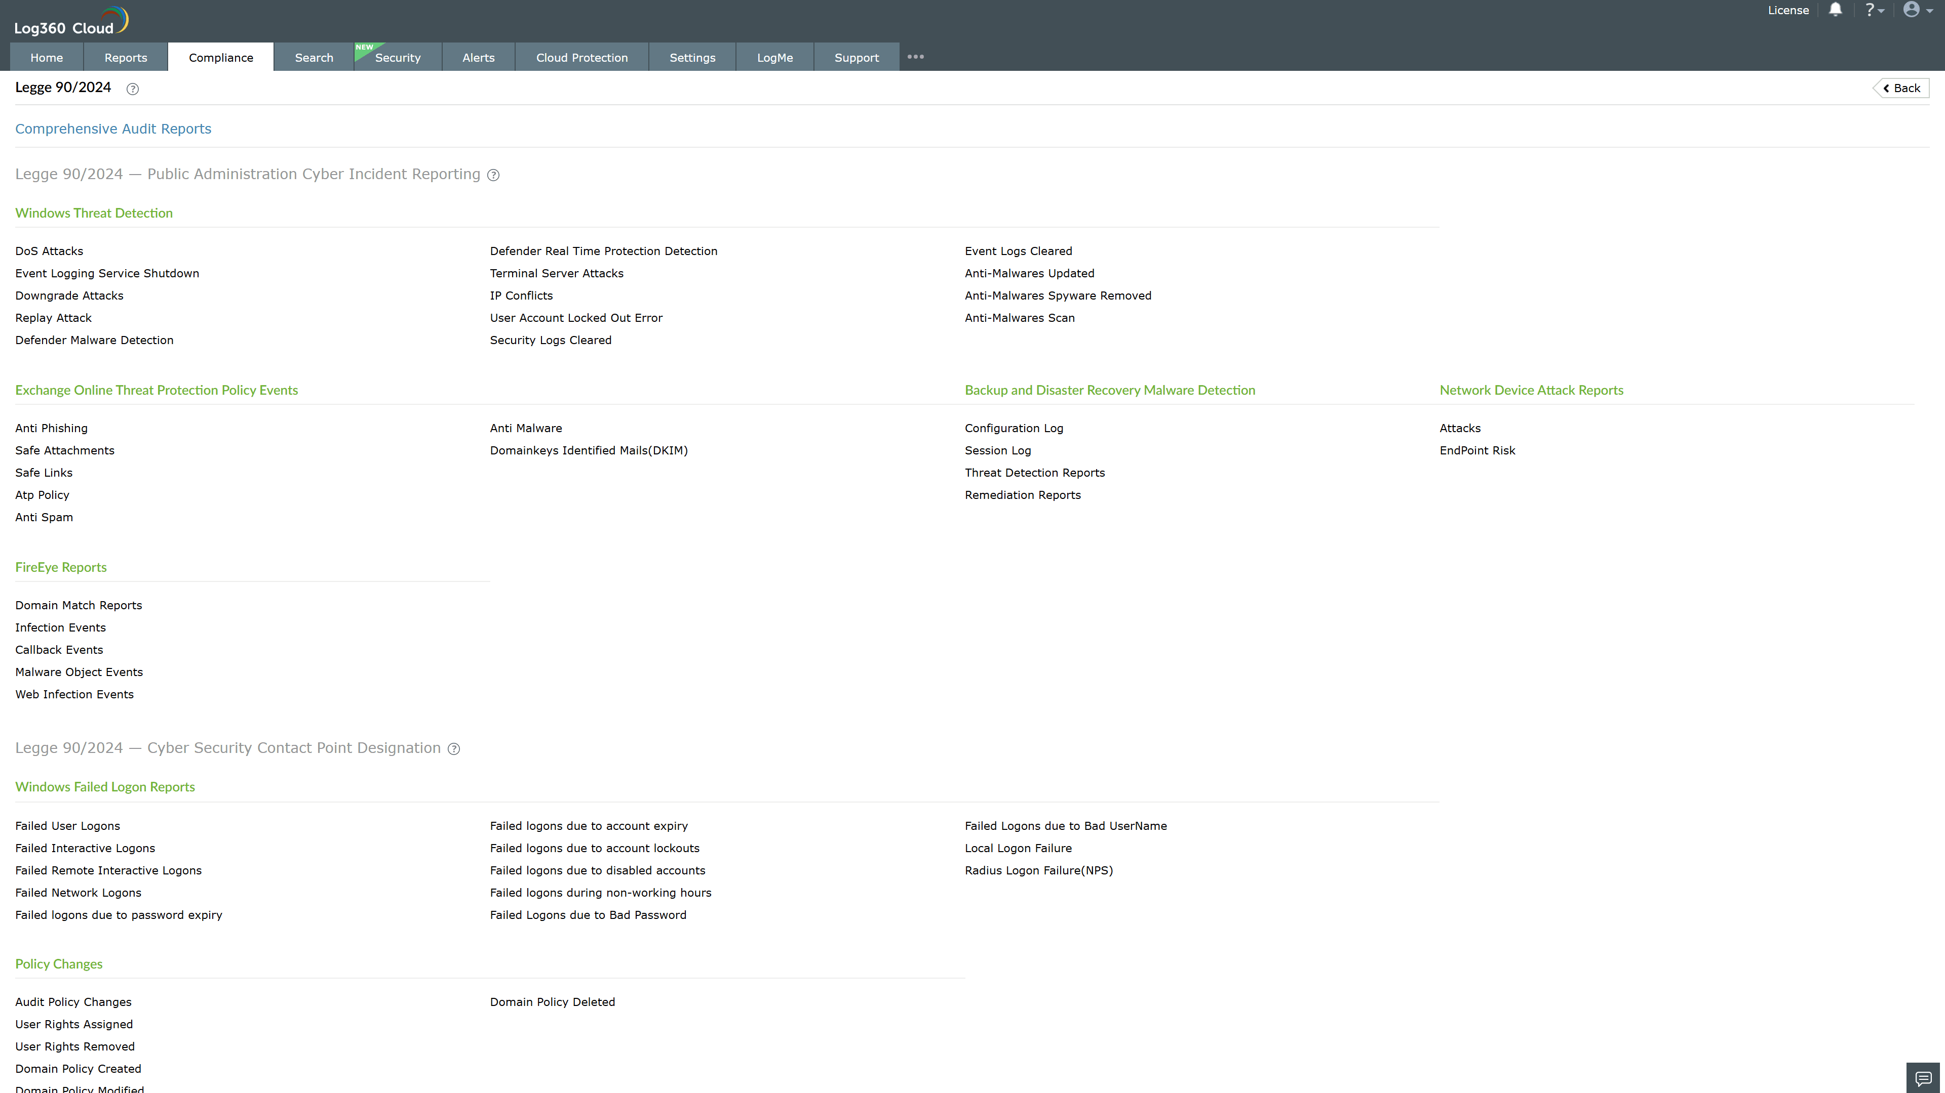
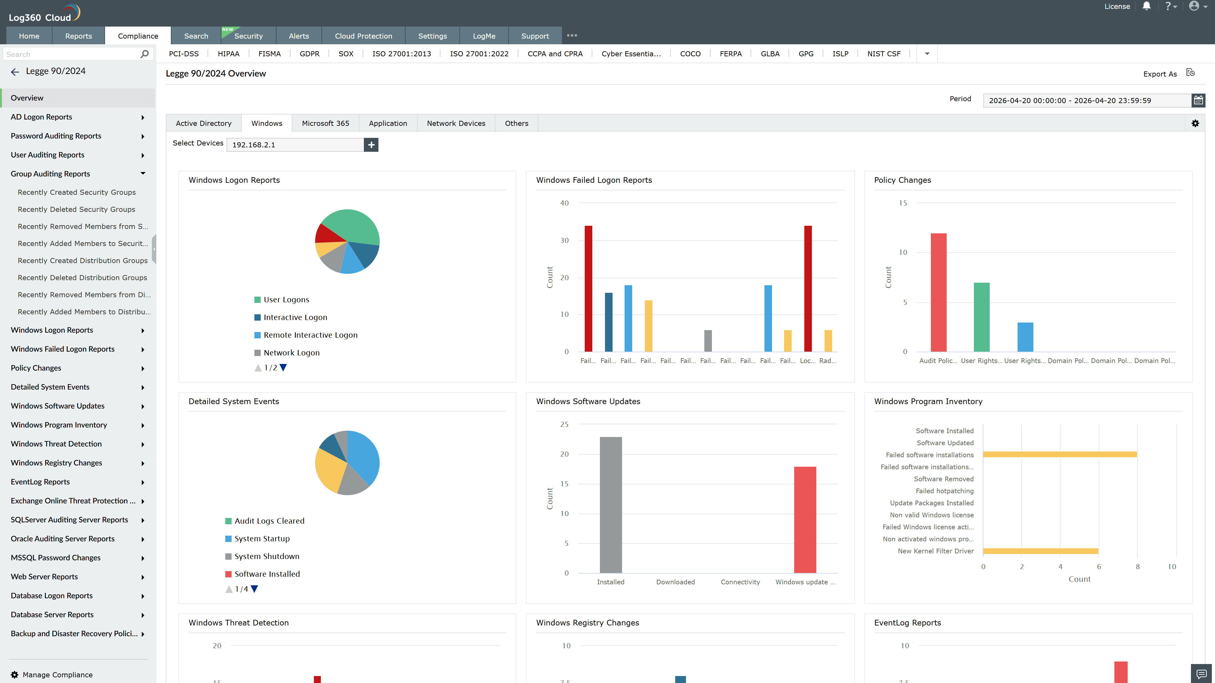
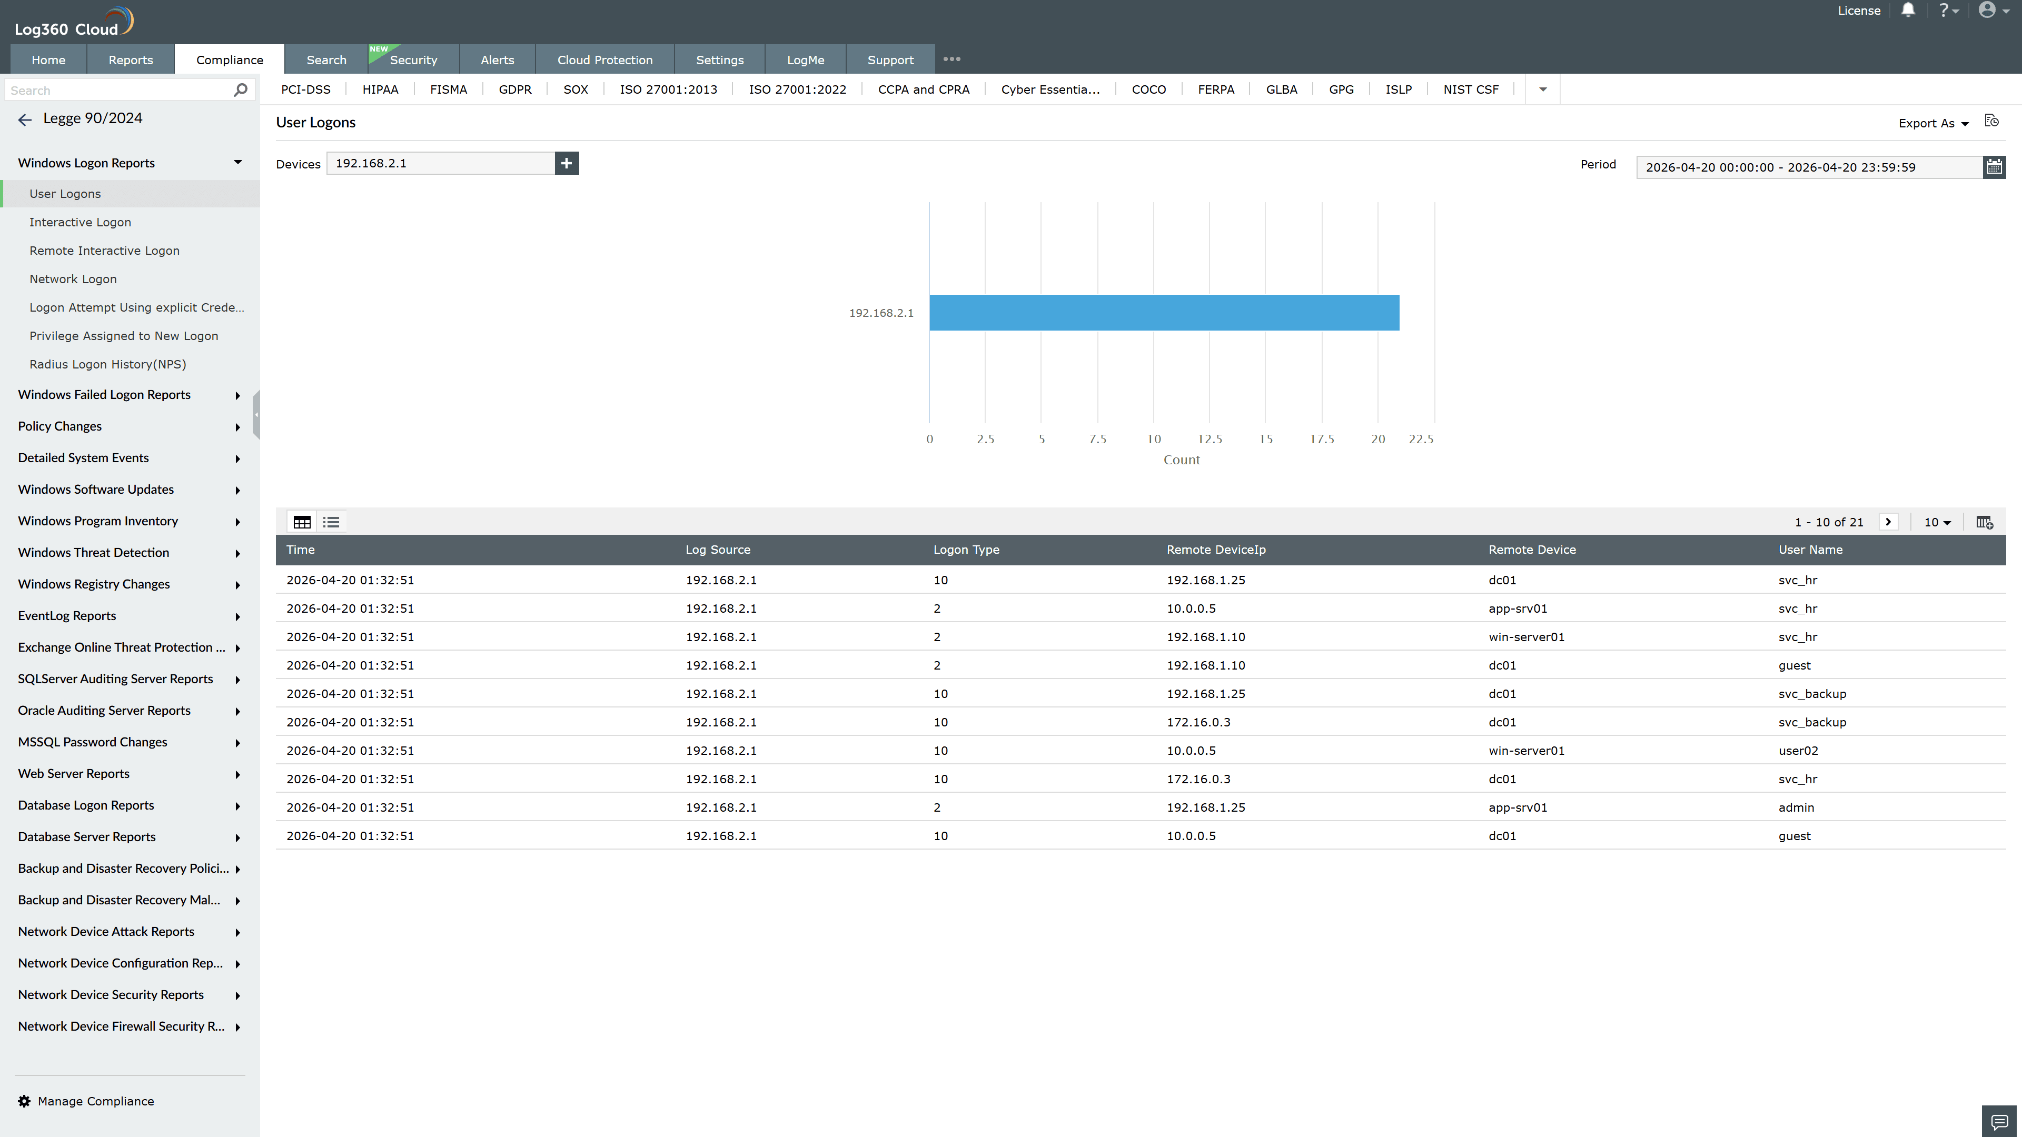
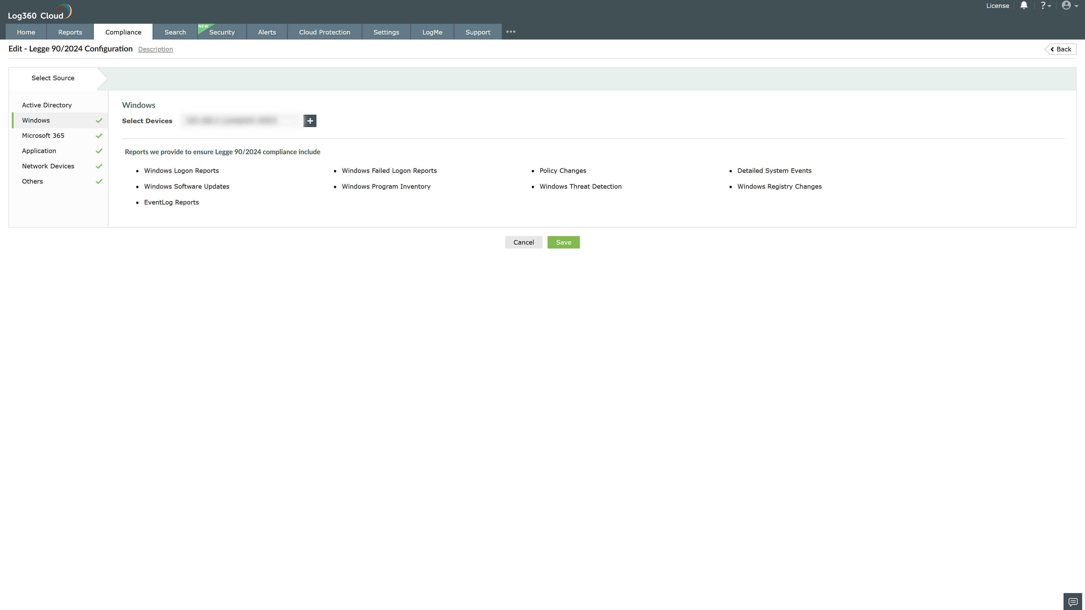

Valid Submission : Yes
Supported Editions : Free, Basic, Standard, Professional, MSSP
Help Document : https://www.manageengine.com/log-management/help/integrations/compliance-extensions.html
Help Video : Not provided
Tags : Log360, Compliance, Privacy monitoring, Data privacy, Regulatory compliance
Supported DCs : US, IN, JP, CA, AU, UK and EU
Privacy Policy:
Terms of Service:
Release Notes:
Predefined reports for the Italian Cybersecurity Law 90/2024 Compliance

